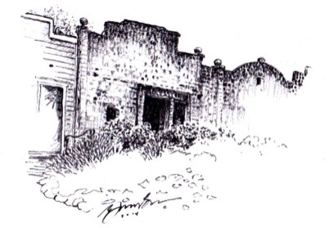
Club Soda Rock

of alexander valley

OF ALEXANDER VALLEY

WINE CLUB SHIPMENT SCHEDULE 2017
VINEYARD CLUB MIXED
25% Discount + $5 shipping
12 bottles/4 times a year
Average Shipment Cost of Wine - $400

VINEYARD CLUB RED
25% Discount + $5 shipping
12 bottles/4 times a year
Average Shipment Cost of Wine - $400

February 2017
2015 Viognier, Mendocino
2014 Primitivo, Los Amigos
2013 Cabernet Sauvignon, Smith Orchard
WC 2013 Cabernet Sauvignon, Five Star General Reserve
May 2017
2016 Rosé, Mendocino
2013 Cabernet Sauvignon, Twisted Rail
2013 Cabernet Sauvignon, Spur Hill
WC 2014 Primitivo, Rockpile
September 2017
2016 Sauvignon Blanc
WC 2014 Malbec, Runway Reserve
WC 2014 Petit Verdot, Runway Reserve
WC 2014 Cabernet Sauvignon, Five Star General Reserve
December 2017
2015 Chardonnay, Meola
2015 Primitivo, Lytton Station
2014 Cabernet Sauvignon, The General
WC 2014 Meritage, Bordeaux Blend

March 2017
2015 Chardonnay, Meola
2013 Cabernet Sauvignon, Spur Hill
WC 2013 Cabernet Sauvignon, 5 Star General
WC 2013 Petit Verdot, Runway Reserve
November 2017
WC 2015 Chardonnay, West Soda Rock RSV
2015 Primitivo, Los Amigos
2014 Cabernet Sauvignon, The General
2014 Cabernet Sauvignon, Smith Orch

March 2017
2013 Cabernet Sauvignon, Twisted Rail
2013 Cabernet Sauvignon, Spur Hill
WC 2014 Cabernet Franc, Warm Springs RSV
WC 2013 Malbec, Runway Reserve
November 2017
2014 Cabernet Sauvignon, AV
2014 Merlot, Smith Orchard
WC 2014 Meritage, Bordeaux Blend
WC 2014 Petit Verdot, Runway Reserve

CELLAR CLUB MIXED
25% Discount
12 bottles/2 times a year
Average Shipment Cost of Wine - $400

CELLAR CLUB RED
25% Discount
12 bottles/2 times a year
Average Shipment Cost of Wine - $400

CELLAR CLUB BORDEAUX
25% Discount
12 bottles/2 times a year
Average Shipment Cost of Wine - $400

March 2017
2014 Primitivo, Lytton Station
2013 Cabernet Sauvignon, Twisted Rail
2013 Merlot, Smith Orchard
WC 2013 Cabernet Sauvignon, 5 Star General
November 2017
2015 Primitivo, Lytton Station
2015 Primitivo, Los Amigos
2014 Cabernet Sauvignon, The General
2014 Cabernet Sauvignon, Smith Orch

February 2017
2014 Wild Boar, Red Blend
2014 Primitivo, Los Amigos
2013 Cabernet Sauvignon, Mercantile
WC 2013 Cabernet Sauvignon, Five Star General Reserve
May 2017
2013 Merlot, Smith Orchard
2013 Cabernet Sauvignon, Twisted Rail
2013 Cabernet Sauvignon, Spur Hill
WC 2014 Primitivo, Rockpile
September 2017
2014 Merlot, Smith Orchard
2015 Primitivo, Los Amigos
WC 2014 Malbec, Runway Reserve
WC 2014 Cabernet Sauvignon, Five Star General Reserve
December 2017
2015 Zinfandel, Cake
2015 Primitivo, Lytton Station
2014 Cabernet Sauvignon, The General
WC 2014 Meritage, Bordeaux Blend

WC – Indicates select wines only available in club shipments and re-order, based on availability
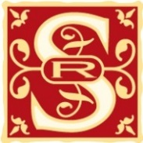
This schedule and price list are subject to change

8015 HIGHWAY 128 Healdsburg, CA 95448 (707) 433-3303 | www.sodarockwinery.com

