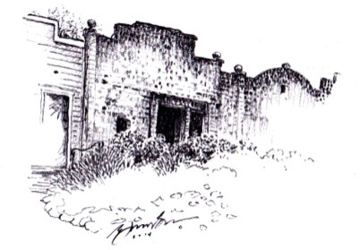
Club Soda Rock

OF ALEXANDER VALLEY

WINE CLUB SHIPMENT SCHEDULE 2017
February 2017
2013 Merlot, Smith Orchard
2013 Cabernet Sauvignon, Mercantile
WC 2013 Petit Verdot, Runway Reserve
May 2017
2014 Zinfandel, Cake
2014 Primitivo, Los Amigos
WC 2013 Cabernet Sauvignon, Five Star General Reserve
September 2017
2014 Cabernet Sauvignon, Alexander Valley
2015 Primitivo, Los Amigos
WC 2014 Malbec, Runway Reserve
December 2017
2014 Merlot, Smith Orchard
2014 Cabernet Sauvignon, The General
2015 Primitivo, Lytton Station

BARREL CLUB RED
15% Discount
3 bottles/4 times a year
Average Shipment Cost of Wine - $100

BARREL CLUB MIXED
15% Discount
3 bottles/4 times a year
Average Shipment Cost of Wine - $100

February 2017
2015 Chardonnay, Meola
2013 Cabernet Sauvignon, Mercantile
WC 2013 Meritage, Bordeaux Blend
May 2017
2016 Rosé, Mendocino
2014 Primitivo, Los Amigos
WC 2013 Cabernet Sauvignon, Five Star General Reserve
September 2017
WC 2015 Chardonnay, West Soda Rock Reserve
2015 Primitivo, Los Amigos
WC 2014 Malbec, Runway Reserve
December 2017
2016 Sauvignon Blanc
2014 Cabernet Sauvignon, The General
2015 Primitivo, Lytton Station

WC – Indicates select wines only available in club shipments and re-order, based on availability
April 2017
2015 Chardonnay, Meola
2013 Cabernet Sauvignon, Mercantile
WC 2014 Primitivo, Rockpile

October 2017
WC 2015 Chardonnay, Alexander Valley Reserve
2014 Cabernet Sauvignon, The General
2014 Cabernet Sauvignon, Spur Hill

April 2017
2013 Merlot, Smith Orchard
2013 Cabernet Sauvignon, Mercantile
WC 2014 Primitivo, Rockpile

October 2017
2015 Zinfandel, Cake
2014 Cabernet Sauvignon, The General
2014 Cabernet Sauvignon, Spur Hill

CASK CLUB RED
20% Discount
6 bottles/2 times a year
Average Shipment Cost of Wine - $200

CASK CLUB MIXED
20% Discount
6 bottles/2 times a year
Average Shipment Cost of Wine - $200

This schedule and price list are subject to change

8015 HIGHWAY 128 Healdsburg, CA 95448 (707) 433-3303 | www.sodarockwinery.com

